It’s hard to believe that the fall foliage in upon us. Below you will find what is planned for the first term. Please be aware that this plan is not set in stone. Adjusting to the needs of a class is always a teacher’s first priority. Each week there will be a weekly newsletter published which will explain homework and what is happening in fourth grade. Our class web page is another great source to find information about what is happening in the classroom. (www.mrferguson2010.weebly.com)

Reading
In reading this term, the focus will be on developing reading strategies for both fiction and non-fiction text. Students on a daily basis will work with a variety of text including news articles, non-fiction books, and short passages to develop their skills as a reader. There will also be several read aloud novels. The first read aloud novel is Where the Mountain Meets the Moon, by Grace Lin along with several other in-class discussion novels. With all novels, the students will be asked to explore the main idea and engage in discussions. The children will demonstrate comprehension and inference skills through detailed verbal and written responses. In addition, there will be opportunities for silent reading. During these silent reading times, each child will practice his/her fluency with a teacher in a 1 to 1 setting. At home the students are expected to read for half hour each night, maintain a reading log, and passed their Accelerated Reader quizzes. At the end of the month, students will be asked to write a book review on one of the books they completed which will be posted on their website. Overall the students will be expected to analyze and critically think about all the material they read whether it comes from a book, a magazine or the internet.

Language Arts
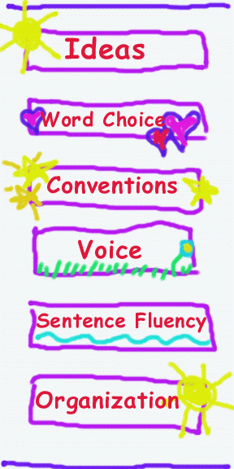
In writing this year, we will continue exploring the seven traits of quality writing which were introduced in third grade. These traits are idea development, organization, sentence fluency, word choice, conventions, voice, and presentation. These traits will be explored through discussion, modeling, reading, and daily writing. Students will also evaluate and critique sample writing pieces to better understand what each one of these traits “feel” and “sound” like. Throughout the trimester, students will maintain a writing journal which will provide them the opportunity to develop the traits of writing. Each month students will be expected to publish one of their writing pieces to their webpage. The other key to successful writing is having the students write for a real purpose. They will practice their writing skills by commenting on other classroom blogs, and published a global newspaper. Outside of writing, student’s grammar and vocabulary skills will be reinforced through Daily Oral Language (grammar) practice each day. Student’s oral language skills will be practiced through the various movie productions. The final component of language arts is spelling and recognizing spelling patterns. Student will have weekly spelling words and homework.

Math
This trimester students will investigate multiplication and division, measurement, and data analysis and probability. In each of these units, the class will use a variety of strategies and models to better understand core mathematical concepts. Students are expected to demonstrate their understanding of the core concepts by showing their thought process, computing accurately and efficiently, and apply multiple problem solving strategies effectively. There will also be opportunity to student to create math tutorials to demonstrate their understanding. In addition to the math units, students will have daily computation and story problems to reinforce their computation and number reasoning skills. By the end of this trimester students are expected to know the multiplication facts up to 12 x 12. A weekly “fast fact” will monitor their progress as well a spreadsheet which records their weekly score.

Science
In science this term, students will be studying the life sciences which look at life cycles, classifications, and the needs of living things. They will learn about these topics through hands on investigations, reading non-fiction materials, and classroom discussion. As part of this unit the students will be growing plants, and recording the changes of a monarch butterfly. An integral part of this unit will be learning about graphing, measurement, and data collection.

Social Studies
This trimester student will begin exploring government. As part of this study the students will travel in September to the Concord State House and Supreme Court. They will also focus on developing map skills and learning the difference between cities, countries, and continents. Throughout the year, students will complete daily geography questions which are geared to increase students’ knowledge and understanding of physical and political aspects of the world as they relate to geography. Students will be using a variety of reference materials when answering the daily questions. In addition to focusing on geography, students will also be exposed to weekly world news and current events.

Socially
This trimester there will be a strong focus on developing a classroom community by accepting others and understanding how to be a positive member of a community. This theme will be interwoven among the subject areas. This agreement has six core expectations which are Be Here, Be Safe, Be Honest, Let Go and Move, Be Responsible and Set Goals. Students will be developing an understanding of what these expectations “looks, sounds, and feels” like through a variety of group initiatives or challenges. They also will be working as community to build a monster as part of the Monster Project, and also participate in the Oreo Challenge. Overall, the goal is to develop a safe and supportive learning environment so each child has the opportunity to succeed.
This is only a general overview of what is happening in fourth grade and there are many more projects like the monster project, the global newspaper, and the Oreo challenge. Check the weekly newsletter or mrferguson2010.weebly.com to keep up with the latest events as new adventures occur every week. If you have any questions about the first term, please don’t hesitate to contact me. I look forward to an exciting and busy year with this great group of students.

